Name: Aaviraj Nikumbh
PRN: 24070126123

Employee.java

import java.time.LocalDate;

abstract class Employee {
protected String name;
protected String PANNo;
protected LocalDate joiningDate;
protected String designation;
protected int empId;

public Employee(String name, String PANNo, LocalDate joiningDate, String designation, int empId) {
this.name = name;
this.PANNo = PANNo;
this.joiningDate = joiningDate;
this.designation = designation;
this.empId = empId;
}

// Abstract Method
public abstract double calcCTC();

public void displayDetails() {
System.out.println("ID: " + empId);
System.out.println("Name :" + name);
System.out.println("Designation :" + designation);
System.out.println("Joining Date: " + joiningDate);
}
}

ContractEmployee.java

import java.time.LocalDate;

class ContractEmployee extends Employee {
private int noOfHours;
private double hourlyRate;

public ContractEmployee(String name, String PANNo, LocalDate joiningDate,
String designation, int empId,
int noOfHours, double hourlyRate) {
super(name, PANNo, joiningDate, designation, empId);
this.noOfHours = noOfHours;
this.hourlyRate = hourlyRate;
}

@Override
public double calcCTC() {
return noOfHours * hourlyRate;
}
}

FullTimeEmployee.java

import java.time.LocalDate;

class FullTimeEmployee extends Employee {
protected double baseSalary;
protected double perfBonus;
protected String role;

public FullTimeEmployee(String name, String PANNo, LocalDate joiningDate,
String designation, int empId,
double baseSalary, double perfBonus, String role) {
super(name, PANNo, joiningDate, designation, empId);
this.baseSalary = baseSalary;
this.perfBonus = perfBonus;
this.role = role;
}

@Override
public double calcCTC() {
if (role.equalsIgnoreCase("SWE")) {
return baseSalary + perfBonus;
} else if (role.equalsIgnoreCase("HR")) {
double hiringCommission = 10000;
return baseSalary + hiringCommission;
} else {
return baseSalary;
}
}
}

Manager.java

import java.time.LocalDate;

class Manager extends FullTimeEmployee {
private double travelAllowance;
private double educationAllowance;

public Manager(String name, String PANNo, LocalDate joiningDate,
String designation, int empId,
double baseSalary, double perfBonus,
double travelAllowance, double educationAllowance) {

super(name, PANNo, joiningDate, designation, empId,
baseSalary, perfBonus, "Manager");

this.travelAllowance = travelAllowance;
this.educationAllowance = educationAllowance;
}

@Override
public double calcCTC() {
return baseSalary + perfBonus + travelAllowance + educationAllowance;
}
}

PayRoll.java
import java.time.LocalDate;

public class Payroll {
public static void main(String[] args) {

FullTimeEmployee emp1 = new FullTimeEmployee(
"Amit", "ABCDE1234F",
LocalDate.of(2022, 5, 10),
"Software Engineer", 101,
500000, 50000, "SWE"
);

ContractEmployee emp2 = new ContractEmployee(
"Ravi", "LMNOP4321K",
LocalDate.of(2023, 1, 20),
"Contract Dev", 102,
100, 400
);

Manager mgr = new Manager(
"Suresh", "ZXCVB9876Q",
LocalDate.of(2020, 7, 1),
"Project Manager", 103,
800000, 100000,
50000, 30000
);

// Output
System.out.println("\n--- Full Time Employee ---");
emp1.displayDetails();
System.out.println("CTC: " + emp1.calcCTC());

System.out.println("\n--- Contract Employee ---");
emp2.displayDetails();
System.out.println("CTC: " + emp2.calcCTC());

System.out.println("\n--- Manager ---");
mgr.displayDetails();
System.out.println("CTC: " + mgr.calcCTC());
}
}

Output:

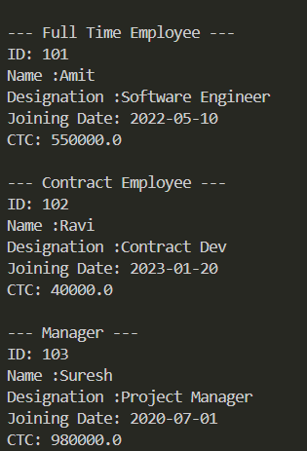

GITHUB:
https://github.com/AaviRaj1702

